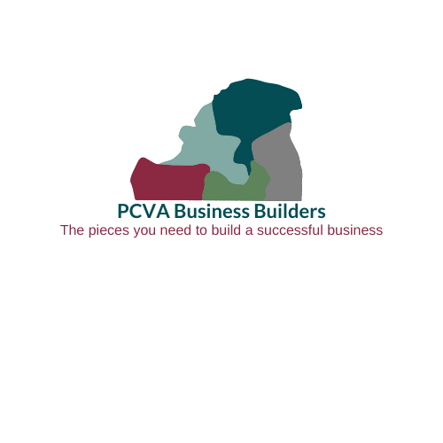
A Small Business Mentoring, Boot Camp
and Business Plan Competition

You are invited to apply to our PCVA Business Builders

The Patrick County Chamber of Commerce operates a business plan competition which includes a requirement to participate in a boot camp to help you evaluate your entrepreneurial mindset readiness, write a business plan, and present a business pitch to compete for funding and receive ongoing mentoring.

Due to limited space, the application process is competitive.
To apply for the startup, download the entire application packet at https://www.patrickchamber.com. Then, complete your application and submit it to director@patrickchamber.com by Friday, July 15, 2022. Applications may also be submitted in person (334 Patrick Avenue, Stuart, VA) or by mail at (P. O. Box 577, Stuart, VA 24171) before 5:00 p.m. on the day of the deadline.
S
Thank you to our Sponsors:


Boot Camp Session Start Dates
Startup Boot Camp (8 weeks):
Tuesday, August 2, 2022, 5:30 PM until 8:30 PM. This will be an in person class. All classes will be held at P&HCC Patrick County Site, unless otherwise notified. Attendance is Mandatory.
Startup sessions will conclude on September 27, 2022. We will have no class on September 13, 2022.

The Chamber partners with Patrick & Henry Community College (P&HCC), Longwood Small Business Development Center, Patrick County Tourism, Economic Development Authority, private funders, a host of talented entrepreneurs and business professionals in our community to provide this initiative to build our entrepreneurial community.

Thank you to our Small Business Development Partners:



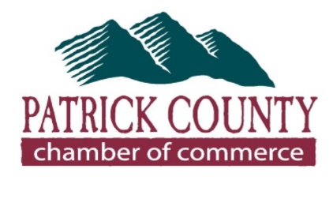
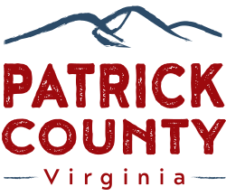

PCVA Business Builders

A Business Mentoring, Boot Camp and Business Plan Competition

Application Deadline: Friday July 15, 2022 (limited space available)
Notifications for acceptance to the Boot Camp will be sent by Tuesday, July 26, 2022.

All information on this application is confidential and will only be shared with program staff and selection committee.

Applicant Information:
- Name: (Individual applying to the program):_______________________________________
- Address: __________________________________________________________________
- Phone Number: ____________________ Alternate Phone Number: ____________________
- E-mail Address: _____________________________________________________________
- Primary Owner of Business: ___________________________________________________
Co-owner(s) (if applicable) _____________________________________________________
Each co-owner must complete a separate application.
- Business Name (only if already known): ___________________________________________
- Is business currently in operation? _______Yes _______No
- Business Address (only if in operation): ___________________________________________
- How long has your company been in business? _____________________________________
- If you are currently operating a business in the Town of Stuart, do you have a current business license? _______Yes ________No
- Capital needed to start or grow business: $______________________
- Capital/Equity you already have in place (how much money do you have to invest or what have you already invested?): $____________________________________
- Amount of assistance you are seeking from this program (may include in-kind support – please specify): $_________________________________________
- Specific items you wish to receive funding to secure: _________________________________

Application is continued on next page.

PCVA Business Builders Application 2022 – Page 2
- What industry best describes your business? (for example, manufacturing, retail, restaurant, service, etc.) ________________________________________________________________
- What do you wish to receive from this program other than funding? _____________________
- Do you have any financial issues that may prevent you from leasing space or obtaining a business loan in the future? (Note: It is important to alert us to any issues so that we may immediately work with you to try to improve your position should this be a potential issue.) __________Yes __________No
___________________________________________________________________________
___________________________________________________________________________
- Describe your business, product, or service and what differentiates it from your competitors (be as specific as you can in describing your business so that it is clear what you have to offer and how it may differ from existing products or services – you may also provide your response as an attachment):
___________________________________________________________________________
___________________________________________________________________________
___________________________________________________________________________
___________________________________________________________________________
___________________________________________________________________________
- Do you identify yourself as “business coachable”? ________ Yes ________No
If yes, please describe your understanding of being “business coachable.” ________________
___________________________________________________________________________
___________________________________________________________________________
__________By initialing here, I certify that I have read guidelines about PCVA Business Builders and understand that I may or may not be selected to participate in the program which offers training, mentoring, networking opportunities and potential monetary awards. If selected to participate in the program, I understand that I must attend scheduled trainings and events and participate as an engaged member of the group. By applying to this program, I understand that my images or videos of me may be used to promote this program and those images and videos are wholly owned by the Patrick County Chamber of Commerce and may also be used by partners of the PCVA Business Builders. If my business or business idea is selected as an award winner, I must establish the eligible business within the Town of Stuart and/or Patrick County, Virginia. I will use the funds for the qualified business expenses, and I will provide all requested reporting including financial documentation.

____________________________________
Business Owner Signature

Understanding of Guidelines Agreement - 2022

Directions: Read each point, then initial that you have read and comprehend. At the end, please print your name and provide signature indicating that you understand these guidelines and choose to apply and, if selected, participate in PCVA Business Builders. If there are multiple business owners, each individual is required to complete this form.

- I understand that attendance in all 8 sessions is mandatory to be eligible for the awards, and I have read the Attendance Policy, which states:
Participants are expected to attend all 8 class sessions. The only excused absences that can be made up include documented sickness and immediate family emergency or death and work-related activity. Participants with an excused absence must meet with the instructor to make up any missed work before the next scheduled class. Participants with an unexcused absence will be ineligible to compete for grant funds at Pitch Night. Even with an excused absence, failure to meet with the instructor and/or to make up missed work before the next scheduled class also may result in participants’ ineligibility to compete for grant funds at Pitch Night. ________
Initial

- I confirm that my business is not a unit of government, is not a nonprofit and is not a multi-level or pyramid business. _____
Initial

- Eligible types of businesses include legal, profit businesses with a physical business location in the Town of Stuart or Patrick County, Virginia, with the exception of pyramid or multi-level marketing companies, which will contribute to the local tax base and preference is to applicants whose business venture will also create jobs in the Town of Stuart or Patrick County, Virginia. Nonprofit organizations may apply to the program; however, no funding will be awarded to nonprofit organizations. _______
Initial

- To be eligible for the awards, I must (1) complete and submit a business plan by Oct 7th, 2022 for Startup participants, (2) participate in Pitch Night, October 11, 2022, for Startup participants, (3) open business in Town of Stuart or Patrick County, Virginia by August 1, 2023, and (4) request for reimbursement by August 30, 2022_. _______
Initial

- To help the Patrick County Chamber of Commerce meet funder’s required funding guidelines, I understand that award winners will be required to provide written progress reports and document business expansion through a signed performance agreement for a period of three years following the opening of my business. ________
Initial

- In an effort to assist the Selection Committee with evaluating my ability to obtain potential business credit including the lease or purchase of a facility, supplies or inventory, I understand that I am required to share any potential issues that may be obstacles to my success and that I am required to provide my numerical credit score in my business plan. ________
Initial

- I have read and understand all of the Award Guidelines.
Generally, legitimate business expenses that assist in starting or expanding business are appropriate uses of award money. This may include, for example:

- Purchase of equipment, property (real estate), supplies, tools, or vehicle (if necessary for the business) or
- Website and/or brand development, and
- Marketing materials and marketing expenses.
- Accounting or human resources consulting.
- Rental fees for up to 1 year

These funds should not be used for salaries/wages, general overhead expenses (example: utilities, fees, etc.), or included in general funds for the business. Use of the award money should be used for needs identified in the business plan. ________
Initial

I, ________________________________________________, understand these guidelines and choose to participate in PCVA Business Builders.

____________________________________ ____________________
Signature Date

Checklist for PCVA Business Builders Participants
In order to be considered for funding, participants must submit the following:
- Completed Application and Understanding of Guidelines Agreement (all sections must be completed) by Friday, July 15, 2022, deadline.

- Complete Business Plan (Completed by Friday October 7, 2022).
- Executive Summary
- Detailed Business Description
- Marketing Plan
- Define Target Market including demographics, market segmentation
- Competitive Analysis
- Pricing Strategy
- Marketing Communication Methods
- Marketing Budget
- Human Resources/Management Plan
- Define team members (short and long term)
- Job descriptions
- Salary and wage plan
- Financial Forecasts
- List of capital equipment/real estate
- 12-month projected income and expenses (showing sources and uses of funds)
- Balance sheet (assets, liabilities, and equity)
- Break-even analysis

- Documented Meetings with Longwood Business Development Center Director – minimum of 1 meeting prior to business plan deadline.

- Acceptable Attendance Record for Boot Camp (Patrick & Henry Community College will provide the attendance status for each participant.)
- Startup boot camp will be held:
- Tuesday, August 2, 2022
- Tuesday, August 9, 2022
- Tuesday, August 16, 2022
- Tuesday, August 23, 2022
- Tuesday, August 30, 2022
- Tuesday, September 6, 2022
- Tuesday, September 20, 2022
- Tuesday, September 27, 2022

- PCVA Business Builders Business Plans due Friday, October 7, 2022.

- PCVA Business Builders Pitch Night participation Tuesday, October 11, 2022.

Note: Dates may be adjusted due to inclement weather.

